Do Microbes Trigger Alzheimer’s Disease?

The once fringe idea is gaining traction among the scientific community.
By Jill U. Adams | September 1, 2017
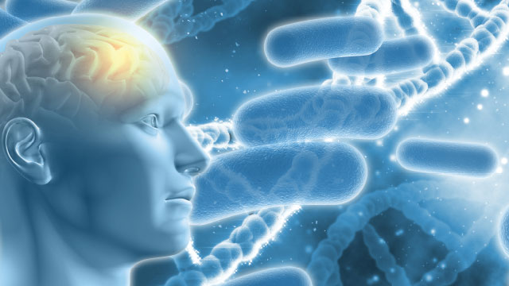
In late 2011, Drexel University dermatology professor Herbert Allen was astounded to read a new research paper documenting the presence of long, corkscrew-shape bacteria called spirochetes in postmortem brains of patients with Alzheimer’s disease.1 Combing data from published reports, the International Alzheimer Research Center’s Judith Miklossy and colleagues had found evidence of spirochetes in 451 of 495 Alzheimer’s brains. In 25 percent of cases, researchers had identified the spirochete as Borrelia burgdorferi, a causative agent of Lyme disease. Control brains did not contain the spirochetes.
The study made Allen think back to 40 years earlier, when he was an intern at Johns Hopkins University and had treated a patient diagnosed with neurosyphilis, a neurological syndrome that included dementia and resulted from the invasion of the syphilis spirochete into the brain. “The parallel between Lyme disease and syphilis had me intrigued,” he says.
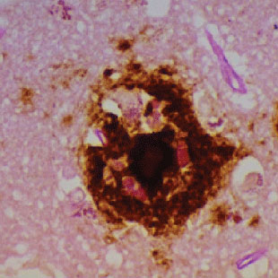Hippocampal section of human brain with Alzheimer’s disease that shows costaining of biofilms and amyloid-β.COURTESY OF HERBERT ALLEN
Allen had recently proposed a novel role for biofilms—colonies of bacteria that adhere to surfaces and are largely resistant to immune attack or antibiotics—in eczema. He suggested that because biofilms block skin ducts and trigger innate immune responses, they may cause the stubborn skin condition. Allen knew of recent work showing that Lyme spirochetes form biofilms,² which led him to wonder if biofilms might also play a role in Alzheimer’s disease. When Allen stained for biofilms in brains from deceased Alzheimer’s patients, he found them in the same hippocampal locations as amyloid plaques.³ Toll-like receptor 2 (TLR2), a key player in innate immunity, was also present in the same region of the Alzheimer’s brains but not in the controls. He hypothesizes that TLR2 is activated by the presence of bacteria, but is locked out by the biofilm and damages the surrounding tissue instead.
Spirochetes, common members of the oral microbiome, belong to a small set of microbes that cross the blood-brain barrier when they’re circulating in the blood, as they are during active Lyme infections or after oral surgery. However, the bacteria are so slow to divide that it can take decades to grow a biofilm. This time line is consistent with Alzheimer’s being a disease of old age, Allen reasons, and is corroborated by syphilis cases in which the neuroinvasive effects of spirochetes might appear as long as 50 years after primary infection.
Allen’s work contributes to the revival of a long-standing hypothesis concerning the development of Alzheimer’s. For 30 years, a handful of researchers have been pursuing the idea that pathogenic microbes may serve as triggers for the disease’s neuropathology. Most came across the connection serendipitously, as Allen did, and some have made it their life’s work, in spite of scathing criticism and related challenges in attracting funding and publishing results.
As early as the 1990s, three laboratories in different countries, each studying different organisms, had each implicated human pathogens in the etiology of Alzheimer’s disease.
“There have been all these observations over time,” says Miklossy. Although she says she’s been dismissed as an “idiot” and denied funding, she continues to pursue spirochetes as an instigating factor in Alzheimer’s disease. “I’m a physician who believes in the Hippocratic Oath,” she says. “We have to do everything we can.”
And the Alzheimer’s field seems primed for a fresh look at a theory that might account for the disease’s pathogenesis. Researchers still cannot say with confidence which features of the disease, such as neuroinflammation, tau tangles, and amyloid plaques, are involved in disease progression and thus would make effective targets for treatment. So far, most drugs that have made it to clinical testing have targeted the amyloid-β peptide, the main component of the amyloid plaques that characterize Alzheimer’s brains. The idea is that a build-up of amyloid-β causes the neuropathology and that removing amyloid-β—by decreasing its production, impeding aggregation, or aiding removal of the molecule from the brain—will improve, or at least stall, symptoms of dementia. But so far, researchers have come up empty-handed.
Last November, for example, a Phase 3 trial of Eli Lilly’s amyloid-targeting antibody solanezumab revealed no improvement in patients in early stages of the disease. This costly and crushing failure was followed up a few months later with another, when Merck halted its clinical trial of the small-molecule drug verubecestat, which blocks the enzyme that yields amyloid-β, in patients with mild to moderate disease. A trial using verubecestat in the earliest diagnosable stage of the disease is still underway.
And these are just the latest in a string of experimental drugs for Alzheimer’s disease that have failed to show any benefit in clinical trials. Some blame the trials themselves for these high-profile flops. “The quality of the clinical trials has been low,” says John Hardy, a molecular neuroscientist at the University College London, pointing out that a couple of the drugs didn’t even make it into the brain.4 But other researchers question the underlying theory.
In light of continued failures to develop effective drugs, some researchers, such as Harvard neurobiologist Rudolph Tanzi, think it’s high time that more effort and funding go into alternative theories of the disease. “Any hypothesis about Alzheimer’s disease must include amyloid plaques, tangles, inflammation—and, I believe, infection.”

A history of microbial links

Emerging evidence links bacterial or viral infection with the neuropathology of Alzheimer’s disease.
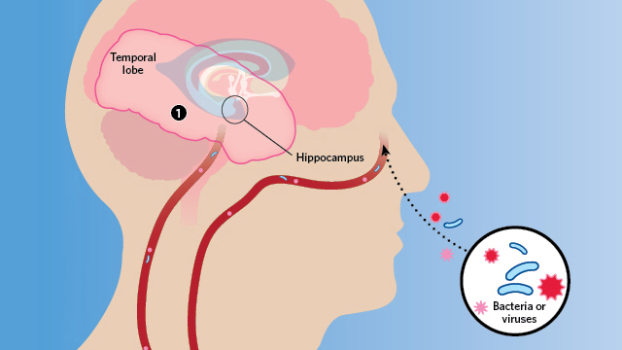
Herpes simplex virus type 1 (HSV1) can acutely infect the brain and cause a rare but very serious encephalitis. In the late 1980s, University of Manchester molecular virologist Ruth Itzhaki noticed that the areas of the brain affected in HSV1 patients were the same as those damaged in patients with Alzheimer’s disease. Knowing that herpes can lie latent in the body for long periods of time, she began to wonder if there was a causal connection between the infection and the neurodegenerative disorder.
Itzhaki began looking for HSV1 DNA in the brains of Alzheimer’s patients—and found it. But the viral DNA also turned up in the brains of age-matched controls. Using PCR, still a new technique at the time, was fraught with difficulty, and Itzhaki’s findings were challenged as resulting from contamination. Itzhaki repeated her work with great care and consistently found that two-thirds to three-quarters of elderly people harbor HSV1 in their brains, whether they had Alzheimer’s or not. So she searched for a genetic difference that might explain why only some HSV1-infected individuals develop dementia. Finally, in 1997, she reported that having both HSV1 in the brain and the apolipoprotein E gene variant APOE4 accounted for 60 percent of the Alzheimer’s cases she considered—much higher than either factor alone.⁵ But most Alzheimer’s researchers still dismissed her work. Itzhaki says her detractors have been set in their ways—and perhaps too wedded to scenarios involving plaques and tangles. “They don’t know anything about viruses,” she says, especially the fact that herpes can linger in the body and brain. “If we say the virus causes this, they imagine the scenario is fast. It’s incredibly naive.”
Around the same time, neuropathologist Miklossy, then at the University of Lausanne in Switzerland, was detailing the brain damage caused by spirochetes—both in neurosyphilis and neuroborrelia, a syndrome caused by Lyme bacteria. She happened upon a head trauma case with evidence of bacterial invasion and plaque formation, and turned her attention to Alzheimer’s. She isolated spirochetes from brain tissue in 14 Alzheimer’s patients but detected none in 13 age-matched controls. In addition, monoclonal antibodies that target the amyloid precursor protein (APP)—which, when cleaved, forms amyloid-β—cross-reacted with the spirochete species found, suggesting the bacteria might be the source of the protein.⁶
Although Miklossy says she received some positive reactions to her findings when she published them in 1993, she, like Itzhaki, also faced her fair share of skepticism. The critiques included comments that the work was “foolish, unorthodox, and crazy,” she adds.
Meanwhile, in the U.S., a third line of evidence linking Alzheimer’s to microbial infection began to emerge. While serving on a fraud investigation committee, Alan Hudson, a microbiologist then at MCP-Hahnemann School of Medicine in Philadelphia, met Brian Balin, who studied neuropathological processes at the Philadelphia College of Osteopathic Medicine. Soon, Balin began to send Hudson Alzheimer’s brain tissue to test for intracellular bacteria in the Chlamydia genus. Some samples tested positive for C. pneumoniae: specifically, the bacteria resided in microglia and astrocytes in regions of the brain associated with Alzheimer’s neuropathology, such as the hippocampus and other limbic system areas. Hudson had a second technician repeat the tests before he called Balin to unblind the samples. The negatives were from control brains; the positives all had advanced Alzheimer’s disease.⁷ “We were floored,” Hudson says.
The paper that Balin, Hudson, and colleagues wrote to announce the findings received worldwide press coverage, says Hudson, now professor emeritus at Wayne State University School of Medicine. But when the authors went to the Alzheimer’s disease meeting, he says, “nobody talked to us.”
Thus, as early as the 1990s, three laboratories in different countries, each studying different organisms, had each implicated human pathogens in the etiology of Alzheimer’s disease. But the suggestion that Alzheimer’s might have some microbial infection component was still well outside of the theoretical mainstream.

New century, new mechanisms
Last year, Itzhaki, Miklossy, Hudson, and Balin, along with 29 other scientists, published a review in the Journal of Alzheimer’s Disease to lay out the evidence implicating a causal role for microbes in the disease.⁸ The paper opens with a plea: “We are researchers and clinicians working on Alzheimer’s disease . . . and we write to express our concern that one particular aspect of the disease has been neglected.”
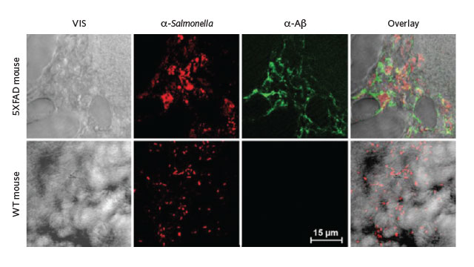
Transgenic mice (top row) whose brains were injected with Salmonella expressed high levels of amyloid-β in those same regions 48 hours later.REPRINTED WITH PERMISSION FROM D.K.V. KUMAR ET AL., SCI TRANSL MED, 8:340RA72, 2016.
George Perry, editor of the journal and an Alzheimer’s researcher at the University of Texas at San Antonio, not only agreed to publish the article, he signed on as an author too. “The Journal of Alzheimer’s Disease promotes all sorts of different ideas,” he says. “We don’t care about popularity.”
And, slowly but surely, Alzheimer’s researchers finally seem to be giving the pathogen hypothesis a good, hard look. Harvard’s Tanzi, one of the newer microbial theorists, has been a prominent figure in the Alzheimer’s field for decades. He contributed to the 1987 discovery of APP, the first Alzheimer’s disease gene. Recently, Tanzi and his colleagues showed that amyloid-β inhibits the in vitro growth of pathogenic bacteria, including Candida albicans, E. coli, and Staphylococcus aureus, suggesting the Alzheimer’s-linked peptide was acting as an antimicrobial.⁹ Tanzi’s working hypothesis is that microbes trigger an innate immune response, in which amyloid-β plays a key role. The peptide surrounds the site of infection to shield healthy tissue from the invaders. Too much clumping, however, can cause problems of its own—the very processes by which plaques trigger neuronal death.
A subsequent study by Tanzi’s group found that amyloid-β binds to microbes and links together with more amyloid-β to entrap the invaders and keep them from interacting with host cells. Indeed, in a transgenic mouse model of Alzheimer’s disease, Salmonella infection seeded amyloid plaques in the brain.¹⁰ “The plaques are generated in the hippocampus and temporal cortex—the regions most susceptible to blood-brain barrier breach,” Tanzi says, suggesting that those areas are where pathogens would first gain entry. “It makes sense to me.”
Tanzi is well aware of the work by Miklossy and others and the criticism that they’ve received. Expecting to get their own dose of criticism, Tanzi says, “we wanted to do everything right, do every control. We spent eight years on this paper.” But to his surprise, the backlash didn’t come. “To our delight, the field looked at what we did,” he says—a sign, perhaps, that the Alzheimer’s research community is finally ready to consider the microbe theory.
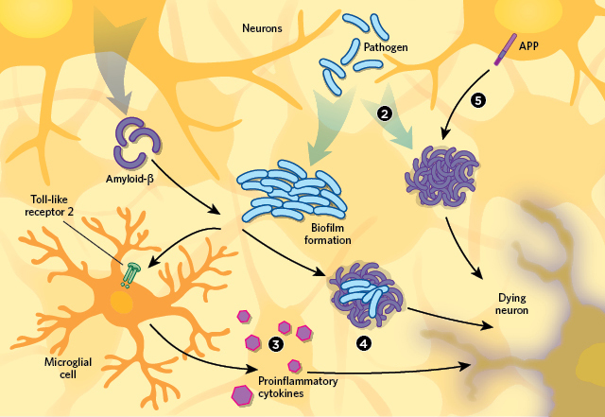
There are several hypotheses to explain the apparent connection between infection and Alzheimer’s neurodegeneration pathology. See full infographic: WEB | PDF© KIMBERLY BATTISTA
Proponents of this idea still face skepticism, however. Elaine Bearer, a molecular neurobiologist at the University of New Mexico Health Sciences Center, received mixed responses when she began publishing and presenting her work linking HSV1 to Alzheimer’s neuropathology. As is a familiar story by now, Bearer had stumbled onto the microbe theory serendipitously.
Her main research interest is how molecular motors pick up cargo in the giant squid axon, and she uses HSV1 as experimental cargo because it’s known to travel in both directions along axonal transport routes. During infection, HSV1 travels from sensory nerve endings to nerve cell bodies where the virus can hole up. When activated, HSV1 travels back out to synapses, reinfects epithelial cells, and voilà—cold-sore recurrence.
In 2006, Bearer found that HSV1 uses APP to attach to axonal transport machinery.¹¹ And as a result, HSV1 redistributes APP within the neuron, she says. That means APP can pile up in ways that don’t happen in uninfected cells. More recently, Bearer showed that “the virus does something to APP,” she says. “In epithelial cells, it induces a 25-fold increase in the protein,” suggesting synthesis of the protein also responds to infection.¹²
Bearer has also produced evidence that HSV1 is trapped in amyloid plaques in human brains. (She has presented this work, but not published it.) This mirrors Tanzi’s findings of Salmonella within amyloid plaques in an animal model, and those of Allen, who found bacterial biofilms colocalized with amyloid-β in human brain tissue.
Despite the increase in evidence supporting the microbial theory of Alzheimer’s disease, however, funding for such research remains difficult to procure. And scientists working in this area also continue to face skepticism from the Alzheimer’s research community. University College London’s Hardy, squarely in the amyloid hypothesis camp, is aware of the work of Itzhaki, Tanzi, and some of the others, but he says he’s still “not convinced.”
Hardy’s main objections are twofold: the idea that microbes cause Alzheimer’s neuropathology doesn’t fully explain the hereditary aspects of the disease, and it doesn’t explain the characteristic anatomical distribution of plaques and tangles in diseased brains. He thinks distribution would be more widespread in the brain with blood-borne disease. “It just doesn’t ring right,” he says. “It doesn’t fit the epidemiology, the neuropathology, or the genetics.” To get him to change his tune, Hardy says, he’d need to see more experimental evidence “to show some element of cause and effect: infect mice, infect primates, and show disease.”
The microbe theorists freely admit that their proposed microbial triggers are not the only cause of Alzheimer’s disease. In Itzhaki’s case, some 40 percent of cases are not explained by HSV1 infection. Of course, the idea that Alzheimer’s might be linked to infection isn’t limited to any one pathogen; the hypothesis is simply that, following infection, certain pathogens gain access to brain, where immune responses result in the accumulation of amyloid-β, leading to plaque formation. In the meantime, with Alzheimer’s patients representing a huge unmet medical need, and experimental drugs often failing in late-stage trials, even Hardy admits that there are more questions than answers at this point in terms of the causative factors in Alzheimer’s. “The pathology is a mess. The brain has been diseased for a long time by the time we see it,” Hardy says. “We’re looking at the end product and trying to determine how it got that way.”
Perry agrees: “Most of the resources in this field are spent on a few biomarkers. All the evidence shows that amyloid is important. But causality and centrality are two different things.”
Jill U. Adams is a freelance science journalist living in Albany, New York.

References
- J. Miklossy, “Alzheimer’s disease - a neurospirochetosis. Analysis of the evidence following Koch’s and Hill’s criteria,” J Neuroinflamm, 8:90, 2011.
- E. Sapi et al., “Characterization of biofilm formation by Borrelia burgdorferi in vitro,” PLOS ONE, 7:e48277, 2012.
- H.B. Allen et al., “Alzheimer’s disease: A novel hypothesis integrating spirochetes, biofilm, and the immune system,” J Neuroinfect Dis, 7:200, 2016.
- E. Karran, J. Hardy, “A critique of the drug discovery and phase 3 clinical programs targeting the amyloid hypothesis for Alzheimer disease,” Ann Neurol, 76:185-205, 2014.
- R.F. Itzhaki et al., “Herpes simplex virus type 1 in brain and risk of Alzheimer’s disease,” Lancet, 349:241-44, 1997.
- J. Miklossy, “Alzheimer’s disease - a spirochetosis?” Neuroreport, 4:841-48, 1993.
- B.J. Balin et al., “Identification and localization of Chlamydia pneumoniae in the Alzheimer’s brain,” Med Microbiol Immunol, 187:23-42, 1998.
- R.F. Itzhaki et al., “Microbes and Alzheimer’s disease,” J Alzheimer’s Dis, 51: 979-84, 2016.
- S.J. Soscia et al., “The Alzheimer’s disease-associated amyloid β-protein is an antimicrobial peptide,” PLOS ONE, 5:e9505, 2010.
- D.K.V. Kumar et al., “Amyloid-β peptide protects against microbial infection in mouse and worm models of Alzheimer’s disease,” Sci Transl Med, 8:340ra72, 2016.
- P. Satpute-Krishnan et al., “A peptide zipcode sufficient for anterograde transport within amyloid precursor protein,” PNAS, 103:16532-37, 2006.
- S.-B. Cheng et al., “Herpes simplex virus dances with amyloid precursor protein while exiting the cell,” PLOS ONE, 6:e17966, 2011.
COMMENTS
September 1, 2017
One of the best quotes about the causes of Alzheimer's disease comes from the same Dr. John Hardy cited in the article:
Dr Carrasco and his team think a clinical trial of anti-fungal drugs is the next logical step. But there is yet another possibility. In the absence of a definitive ultimate cause, it may be that the symptoms of Alzheimer’s disease can arise from many different types of insult to the brain. There have been several papers, says Dr Le Guillou, that have found correlations between various infectious organisms and Alzheimer’s. “It could be a bit like the Mississippi river,” says Dr Hardy. “You can start in all sorts of places, but eventually you’re going to end up in New Orleans.” If Alzheimer’s is a general response to all sorts of neurological triggers then it may be that the fungal infections found by Dr Carrasco are simply one of a long list of causes.
Various infectious diseases (fungal, bacterial, and viral) can contribute to Alzheimer's disease via protein kinase C activation, NMDA receptor activation, and the formation of peroxynitrite. Peroxynitrite can kill infectious agents but it can also cause a series of problems, including brain damage (more on that later).
Without the initial activation of protein kinase C there is no Alzheimer's disease.
Malinow’s team found that when mice are missing the PKC alpha gene, neurons functioned normally, even when amyloid beta was present. Then, when they restored PKC alpha, amyloid beta once again impaired neuronal function. In other words, amyloid beta doesn’t inhibit brain function unless PKC alpha is active.
In addition to amyloid oligomers, fungi, bacteria, and viruses, a variety of other factors activate protein kinase C including but not limited to several air pollutants, mercury, Agent Orange (dioxin), Roundup (polyethoxylated amines), high fructose corn syrup, inustrial solvents, nicotine, psycholoigical stress, and traumatic brain injuries. Instead of looking for one cause of Alzheimer's disease, scientists should be looking for multiple causes and should stop assuming that removing one cause (amyloid oligomers, for instance) is going to stop the onset and progression of Alzheimer's disease.
Peroxynitrite damages the brain in multiple ways. Through oxidation and nitration it inhibits the release and synthesis of neurotransmitters needed for the retrieval of short-term memory, sleep, mood, social recognition and alertness, decreases the regeneration of neurons in the hippocampus and the formation of new synapses, and limits blood flow and the transport of glucose in the brain which can result in delusions. And through DNA damage and the activation of caspase-3, peroxynitrite triggers the death of neurons.
Currently approved medication for Alzheimer's disease slows down the formation of peroxynitrite and the progression of Alzheimer's disease for awhile. Aricept and other acetylcholinesterase inhibitors do so by limiting the release of intracellular calcium which helps to limit protein kinase C activity. Namenda/memantine does so by limiting NMDA receptor activation. But neither drug works well enough to alter the course of the disease. It is like turning down the water in a sink with a stopper. The sink fills up more slowly, but it still fills up.
All Alzheimer's drug would likely work better with peroxynitrite scavengers. The reverse may also be the case. But in any case certain peroxynitrite scavengers such as various antibiotics and the compounds in CBD oil have shown some initial promise in the treatment of the disease. Even more promising for the time being at least are the peroxynitrite scavenging compounds contained in panax ginseng and various essential oils via aromatherapy. These treatment have led to some improvements in cognition (and in the case of heat processed ginseng behavior). in the case of Korean red ginseng, the improvements were sustained for two years.
Peroxynitrite scavengers not only remove peroxynitrite, they help reverse some of the damage done by oxidation and nitration. By themselves and/or in combination with current Alzheimer's disease, they are likely the key to effectively treating Alzheimer's disease.
September 7, 2017
That so many pathogens can be “causing” Alzheimer’s disease (AD), raises many questions; yet, that infection triggers a pro-inflammatory immunity via TLR2 and perhaps others, is a sound proposition. After all, inflammation seems to be a factor that aggravates AD and bacteria/viruses produce many compounds that trigger the inflammatory innate immunity. It has been known that amyloid-β is a danger signal that triggers the production of inflammatory cytokines like IFN-gamma, thus, inflammation is a crucial factor in the worsening of Alzheimer’s. Perhaps, the best proof was the ill-fated AN-1792 vaccine having the strong pro-inflammatory adjuvant QS-21, where a strong inflammatory Th1 response caused damaging side-effects which ended the clinical study. Nonetheless, several new studies used that or similar adjuvants with disappointing results.
Ironically, this article stresses plaque as a villain, but new evidence is showing that many older people with large amounts of cerebral plaque are cognitively normal. Also, old and new data shows that the pathogenic forms are soluble oligomers of amyloid-β that are cytotoxic. Forms that have been largely ignored while focusing on plaque, which apparently is a protective mechanism that acts by sequestering the neurotoxic oligomeric amyloid. Indeed, work from China and Germany has shown that releasing the cytotoxic oligomers from plaque results in death of the neural cells. Actually, many of the failed immune therapeutic methods to “cure” Alzheimer’s have released the trapped amyloid forms without neutralizing their toxicity; a situation that may have been aggravated more by the fact that in many cases the induced immunity has been a pro-inflammatory one. Thus, rather than advocating “new century, new mechanisms” we should be advocating “new century, more rational approach to Alzheimer’s drug development;” since failure to do so will continue the endless series of failures as well as more articles speculating what went wrong.

