Who is eligible to participate?

- Generally healthy, indicated by recent physical examination senior adults (50-85)

- Having a diagnosis of non-vascular early to mid-stage dementia or (MMSE score of 15-25)
- Medical history review and an in-person interview are needed to determine eligibility.
- Caregivers are required to actively participate in the study.

For Details contact:

Marvin H. Berman Ph.D.
PRINCIPAL INVESTIGATOR 315 Yorktown Plaza
Elkins Park, PA 19027 http://quietmindfdn.org/
marvinberman@quietmindfdn.org

Call: 610-940-0488

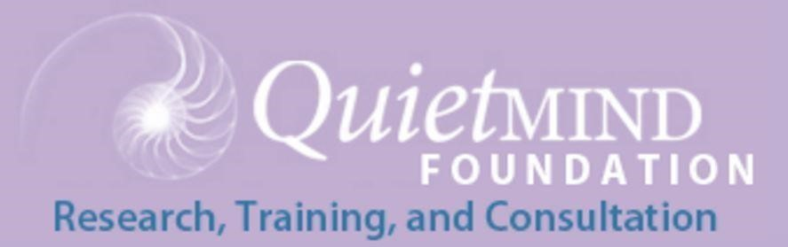
Shining New Light on Dementia Treatment

Quietmind Foundation is recruiting subjects who notice they are having trouble remembering things for a new 60-day, randomized, double-blind, placebo-controlled clinical trial. We want to determine if brief periods of infrared light stimulation directed passively through the scalp can alleviate symptoms of early to mid-stage memory loss (dementia). Selected subjects will, in the privacy and comfort of their home, conduct 56 twice-daily, 6-minute stimulation sessions. Participants’ brain electrical activity, memory and other cognitive abilities will be tested before, during and after the 56-day trial. All services and transportation are provided free of charge, subjects
receive $225 on completion of 3 in-office, 2-hour evaluation sessions.

The primary goal is to determine if intensive near-infrared light treatment will effect significant positive changes in memory and executive function in people with diagnosed memory loss. No treatment currently available has proven effective in slowing or reversing this type of memory impairment and loss of executive functions. This approach could represent a safe, noninvasive, non-drug, self-administered treatment for Alzheimer’s and Parkinson’s disease.

